>1

>printing following pattern by using Bash shell scripting.

1

2 3

4 5 6

7 8 9 10

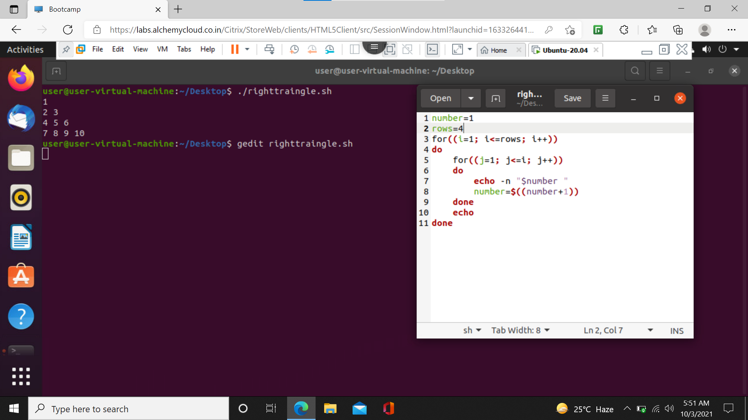

>2

1

1 2

1 2 3

1 2 3 4

1 2 3 4 5

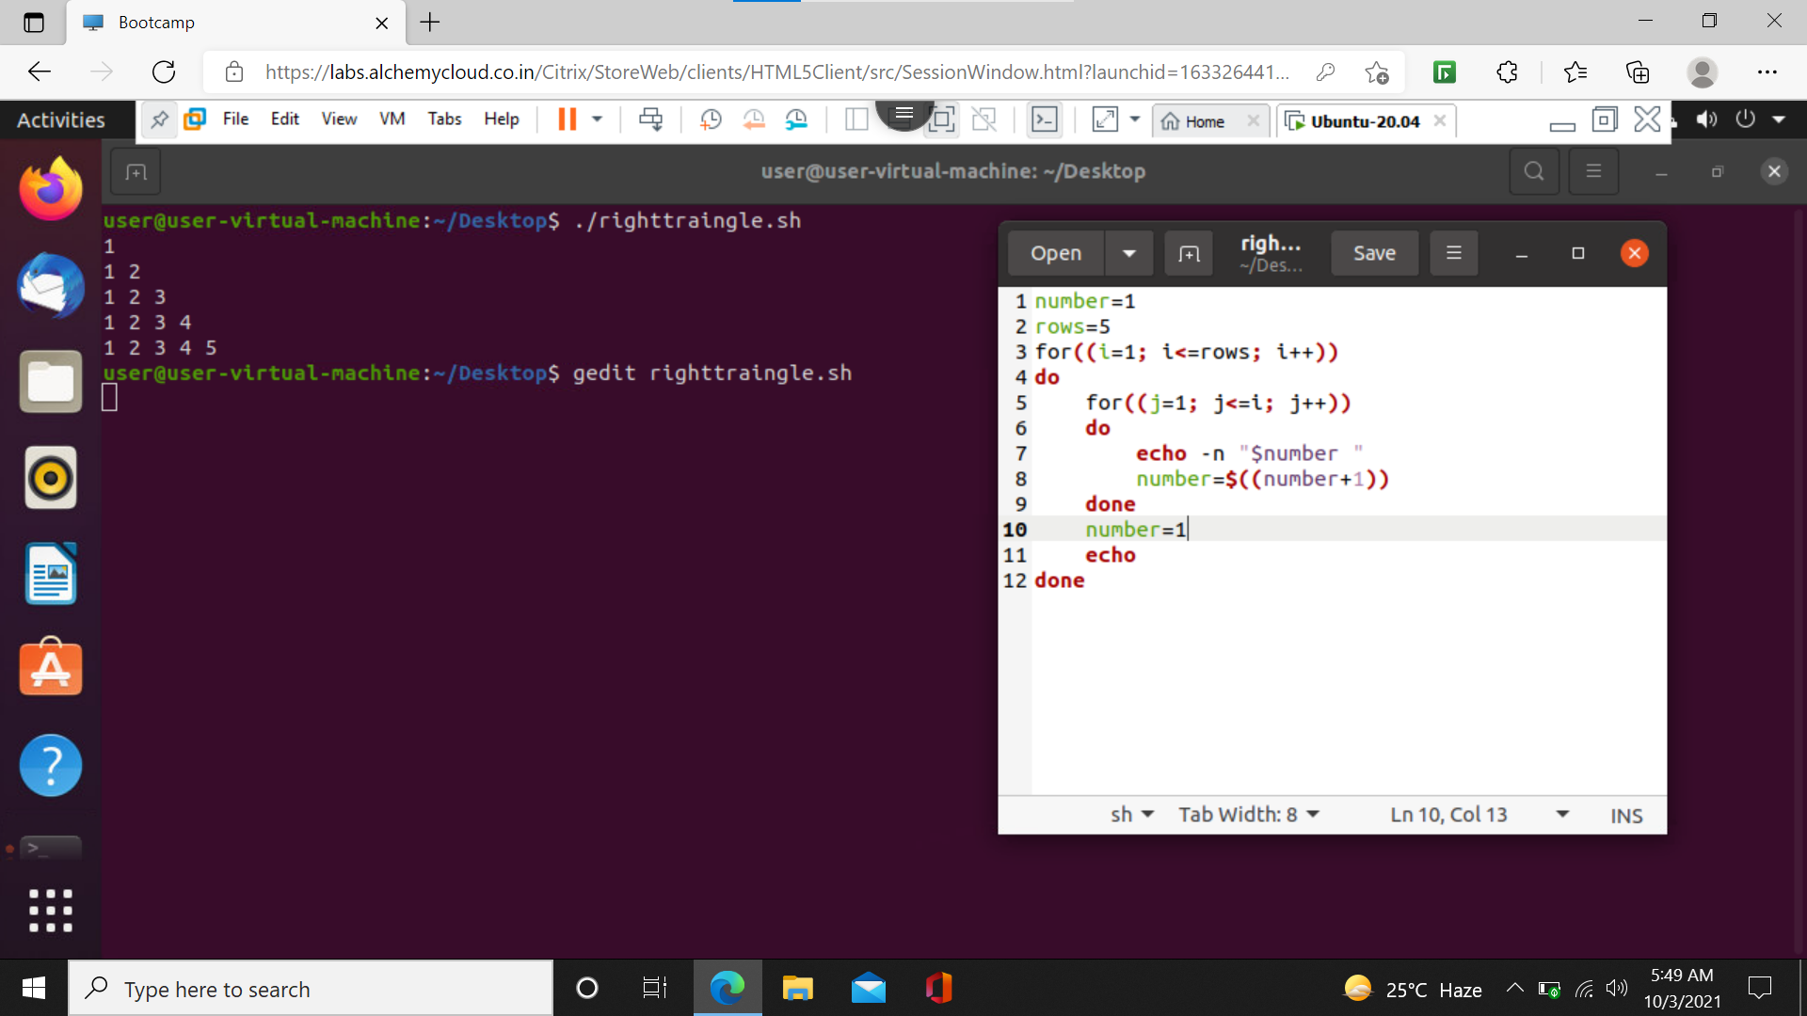

>3

\*

\* \*

\* \* \*

\* \* \* \*

